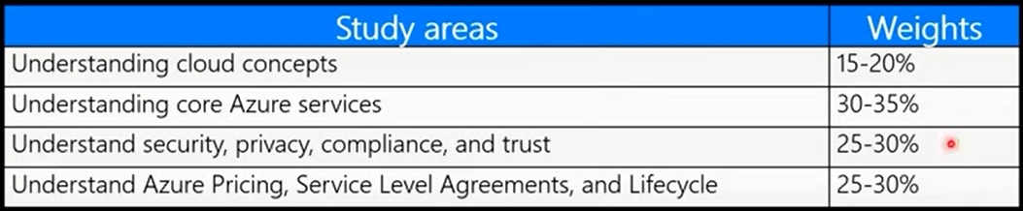

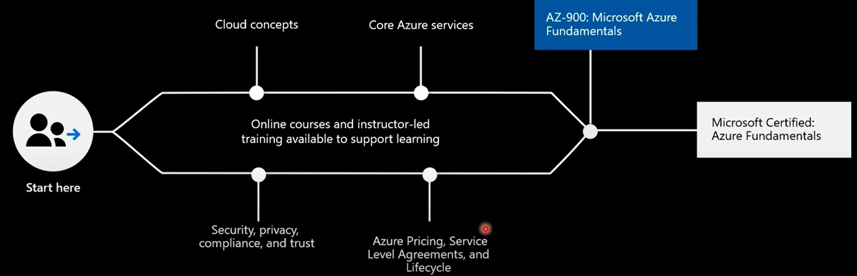

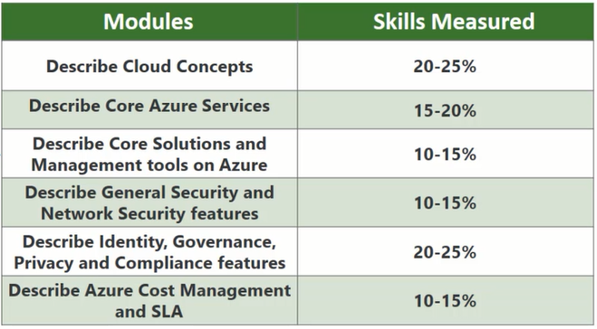

**Discuss why cloud services?**

Define cloud computing:

* Cloud computing is the delivery of Computing services such as server, storage , database networking software analytics and more these are all over through the internet that has been called as the cloud
* helps you lower your operating cost
* Help you run your infrastructure more efficiently and scale as your business needs to change

Benefits of cloud computing

* Available- anywhere , anytime, any device
* Pay as you go
* Scalability and flexibility
* Minimize capital investment
* Higher service quality
* Safety security and compliance

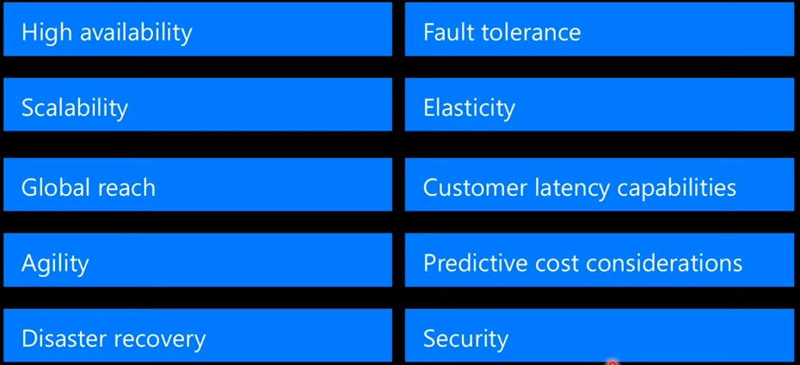

The company providing these services is referred as a cloud provider

* Microsoft azure
* Amazon web services
* Google cloud platform

The cloud provider is responsible for physical hardware required to execute your work in addition to keeping up to date

Every business is unique and has different needs

* Cloud computing provides different services such as
* **Compute** power such as Linux server or windows server or web application
* You need **Storage** such as files and databases
* **Networking** such as secure connection between your cloud provider and your company
* **Analytics** such as visualizing telemetry and performance data

Go to portal.azure.com 🡪 all services

Key concepts:

Economies of scale – cloud providers can reduce costs and gain efficiency when operating at a large scale

CapEx(Capital Expenditure) – spending of money on physical infrastructure

* High upfront cost, value of investment reduces overtime

OpEx(Operational Expenditure)

* Spending on services or products as needed
* No Upfront cost, pay as you use

The advantages of public clouds include:

* No CapEx
* Agility
* Consumption based
* Lower costs
* No maintenance
* Near unlimited scalability
* High reliability

Ex: Microsoft azure

A private cloud is owned and operated by the organization that uses resources from that cloud environment in their own data centre

The advantages of private clouds include:

* Improved Security
* More flexibility
* High Scalability

Ex: medical data

Hybrid cloud : combination of public and private

The advantages of hybrid clouds include:

* Control
* Flexibility
* Compliance
* Cost-effectiveness
* Ease

Ex: hosting a website in the public cloud and linking it to a highly secure database